PROSIDING SEMINAR INTERNASIONAL

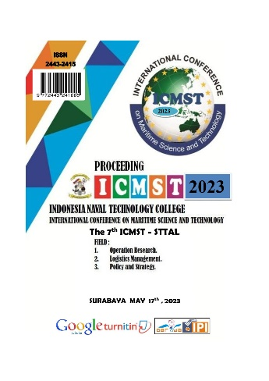
The 7th International Conference on Maritime Science and Technology-2023
Vol 7 No 01 (2023): Indonesia Naval Technology College STTAL Postgraduate International Conference - Proceedings of STTAL Postgraduate International Conference “The 7th International Conference on Maritime Science and Technology” | STTAL POSTGRADUATE - INTERNATIONAL CONFERENCE (seminarpasca-sttal.ac.id)

The 6th International Conference on Maritime Science and Technology-2022
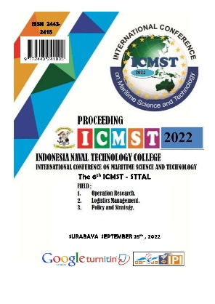
Vol 6 No 1 (2022): Indonesia Naval Technology College STTAL Postgraduate International Conference - Proceedings of STTAL Postgraduate International Conference “The 6th International Conference on Maritime Science and Technology” | STTAL POSTGRADUATE - INTERNATIONAL CONFERENCE (seminarpasca-sttal.ac.id)

The 5th International Conference on Maritime Science and Technology-2021
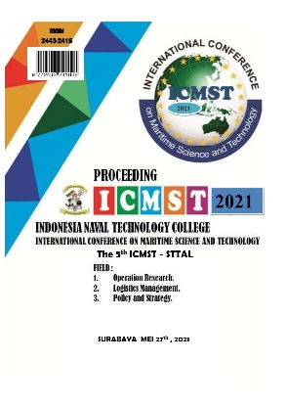
Vol 5 No 1 (2021): Indonesia Naval Technology College STTAL Postgraduate International Conference - Proceedings of STTAL Postgraduate International Conference “The 5th International Conference on Maritime Science and Technology” | STTAL POSTGRADUATE - INTERNATIONAL CONFERENCE (seminarpasca-sttal.ac.id)

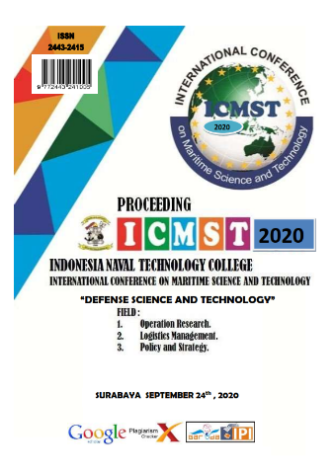
The 4th International Conference on Maritime Science and Technology-2020
Vol 4 No 1 (2020): Indonesia Naval Technology College STTAL Postgraduate International Conference - Proceedings of STTAL Postgraduate International Conference “The 4th International Conference on Maritime Science and Technology” | STTAL POSTGRADUATE - INTERNATIONAL CONFERENCE (seminarpasca-sttal.ac.id)

The 3th International Conference on Maritime Science and Technology-2019
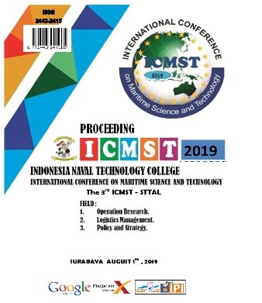
Vol 3 No 1 (2019): Indonesia Naval Technology College STTAL Postgraduate International Conference - Proceedings of STTAL Postgraduate International Conference “The 3rd International Conference on Maritime Science and Technology” | STTAL POSTGRADUATE - INTERNATIONAL CONFERENCE (seminarpasca-sttal.ac.id)

The 2th International Conference on Maritime Science and Technology-2018
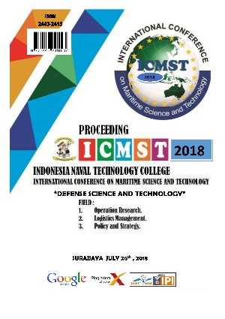
Vol 2 No 1 (2018): Indonesia Naval Technology College STTAL Postgraduate International Conference - Proceedings of STTAL Postgraduate International Conference " DEFENSE SCIENCE AND TECHNOLOGY” | STTAL POSTGRADUATE - INTERNATIONAL CONFERENCE (seminarpasca-sttal.ac.id)

The 1th International Conference on Maritime Science and Technology-2017
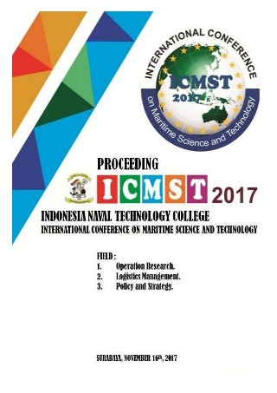
Vol 1 No 1 (2017): STTAL POSTGRADUATE - INTERNATIONAL CONFERENCE ; PROCEEDINGS | STTAL POSTGRADUATE - INTERNATIONAL CONFERENCE (seminarpasca-sttal.ac.id)

